**EYEWITNESS**

***Stories from the Palestine and Israel***

**Hear from Anne Street who has recently returned from 3 months in the West Bank**

* *What is daily life like under the occupation?*
* *What can be done to promote a just peace in Israeli-occupied Palestine?*
* *What is the Israeli peace movement doing?*

**Thursday 16th February 2023**

**7pm- 9pm**

**Palestine Museum**

**27 Broad St, Bristol, BS1 2HG**

*Part of a series of events for*

*the 10th Anniversary of the Palestine Museum and Cultural Centre*



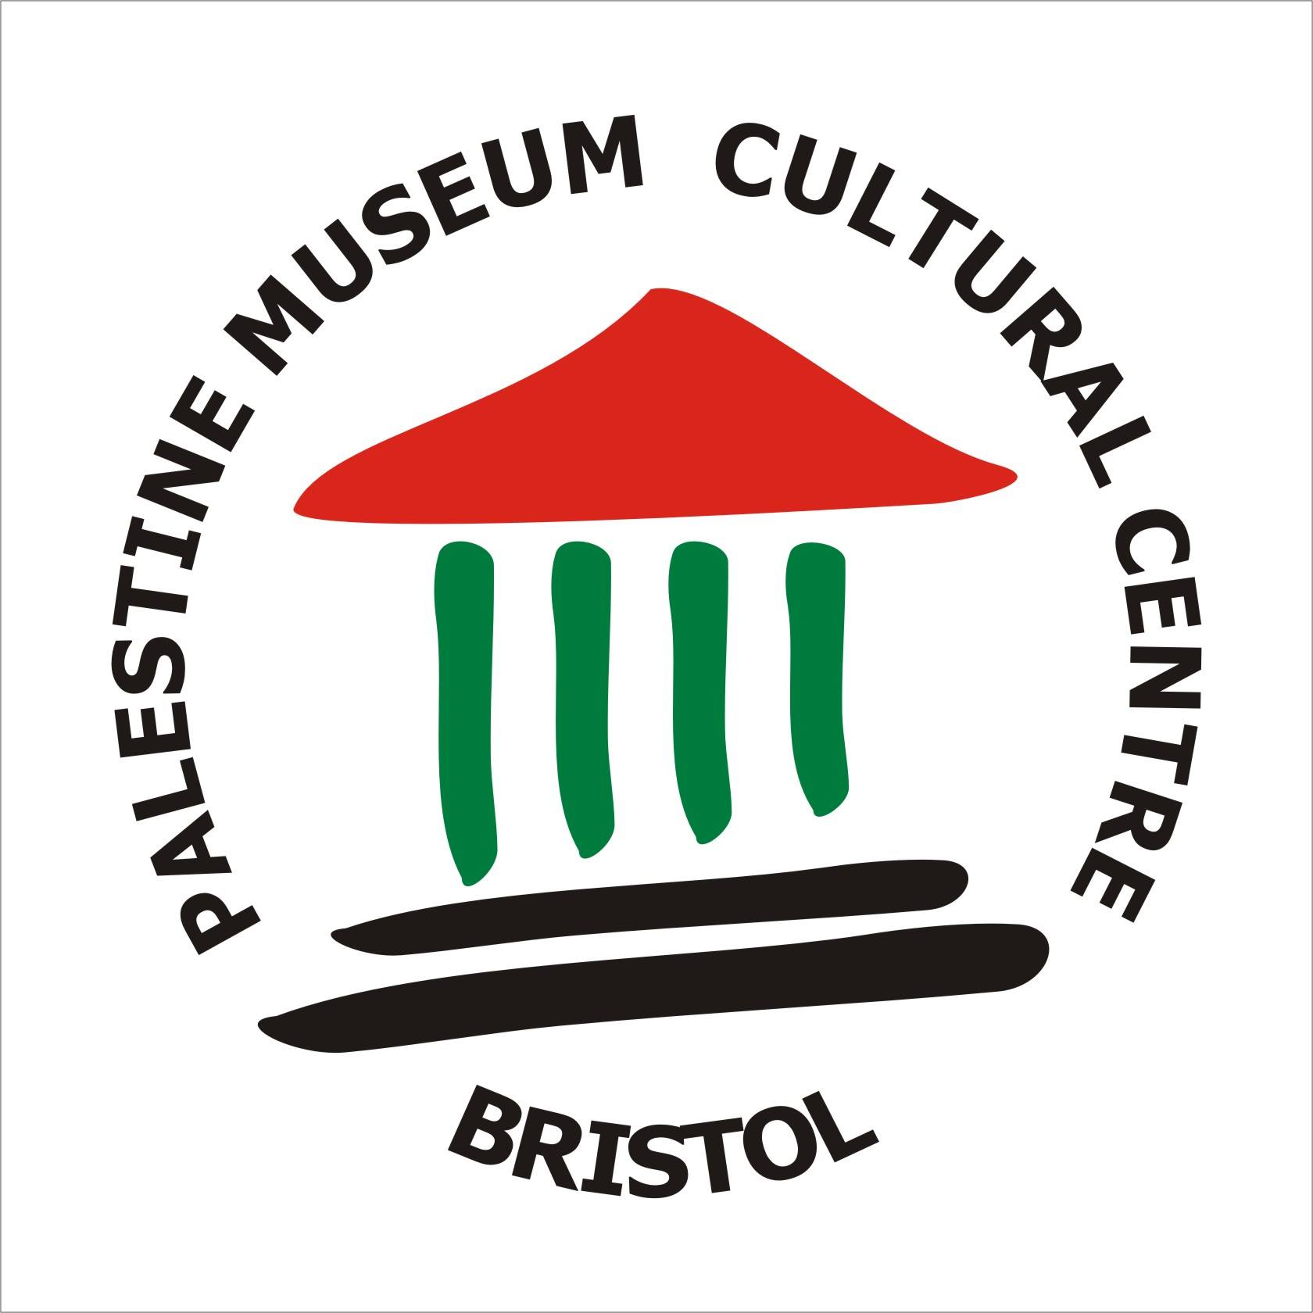

**For more information please contact EAPPI on   
020 7663 1144 or** [**eappi@quaker.org.uk**](mailto:eappi@quaker.org.uk) [www.quaker.org.uk/eappi](http://www.quaker.org.uk/eappi)

[**www.palmuseumbristol.org**](http://www.palmuseumbristol.org) **Free Event Donations welcome**