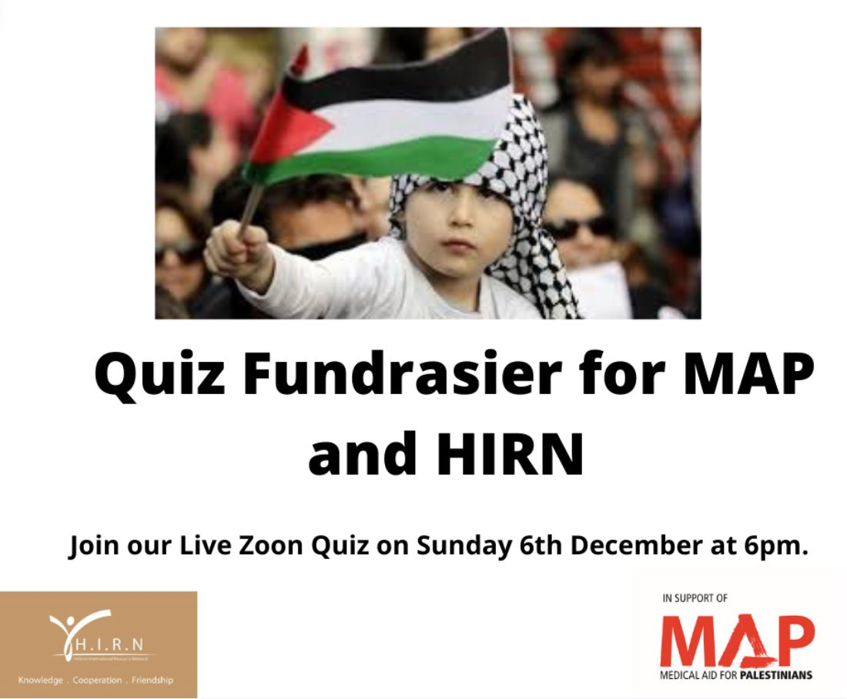

Join us on Sunday 6th December at 6 pm for a fun quiz on Zoom. We are raising vital funds 2 organisations actively involved with providing medical and humanitarian aid for Palestinians. Hebron International Resource Network (HIRN) and Medical Aid for Palestine (MAP) have announced emergency appeals for their critical work on Covid-19 and essential humanitarian aid for Palestinians.

Please email [vivapalestine2020@outlook.com](mailto:vivapalestine2020@outlook.com) to registered for this one-off fun quiz. You will then receive your Zoom invite and can then log on to take part. There is no entrance fee for this quiz. What we do ask, is for all entrants to make a donation to MAP or HIRN. The details of how you can donate will be sent to you when you register for the quiz.

The winners of the quiz will receive a hamper of goodies from Zeytoun.

Thank you so much and I'm looking forward to seeing you on Zoom!