Easy Read | Topic Plastic Police
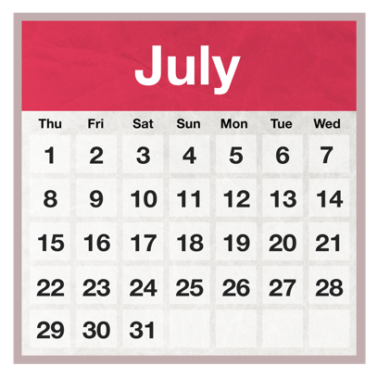 | You are invited – Saturday 6th of July 2024, Bristol.
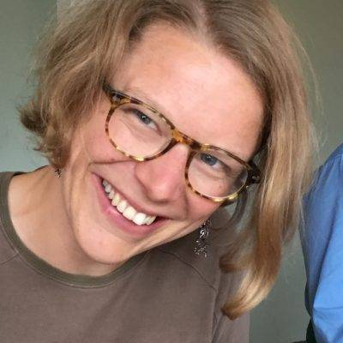 | Hello  My Name is Beth Richards.
 | I am a campaigner in Bristol.
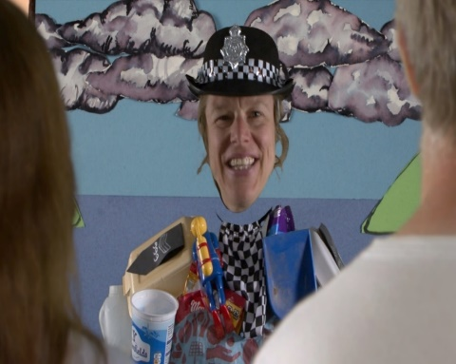 | I have made a film about the environment called Plastic  Police.
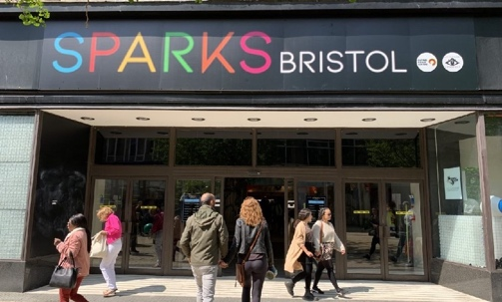 | I will be showing my ten minute animation Plastic Police lots of times during Saturday 6th of July at SPARKS in Bristol.
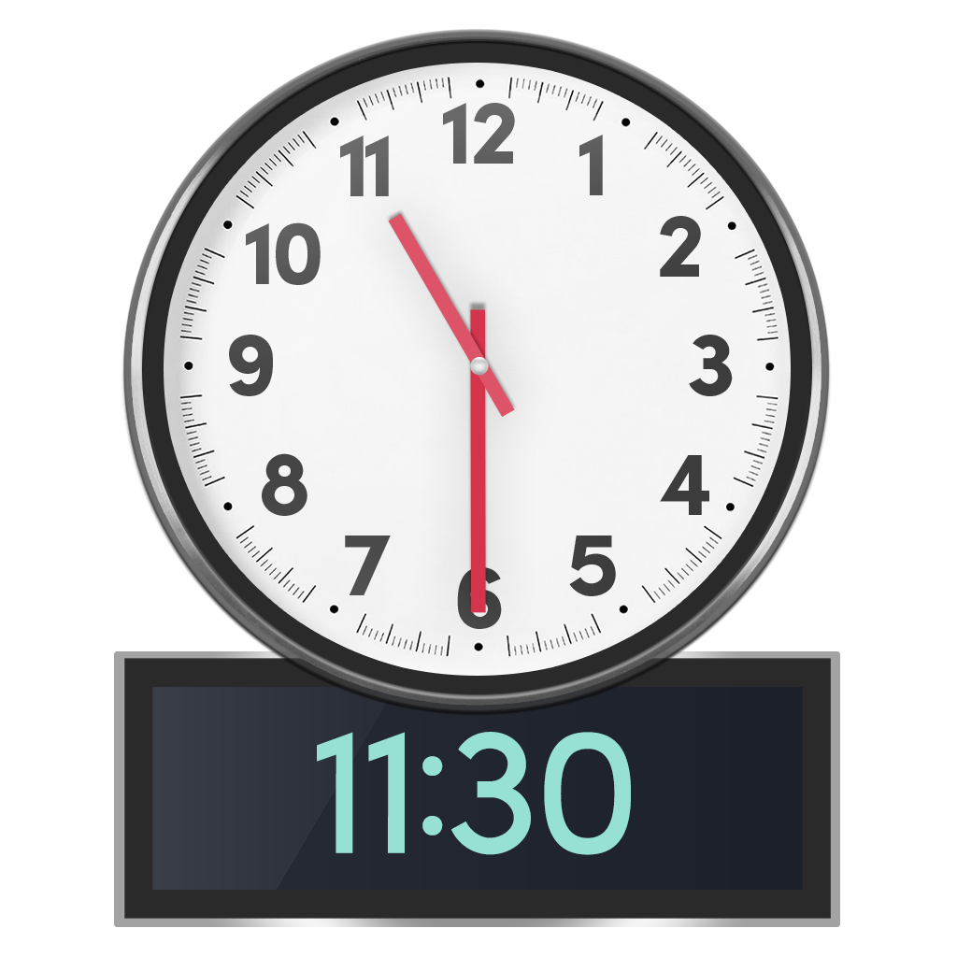  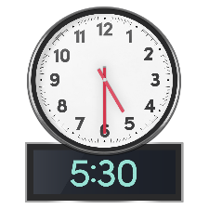 | We’ll start at 11.30  Come whenever you like but  before 5.30!
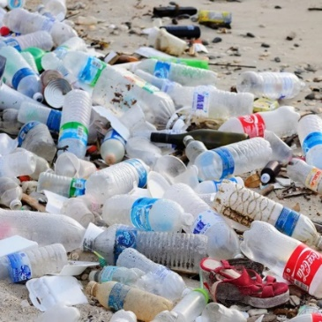 | We will be having chats with everyone about plastic pollution. You’ll be very welcome to join us.
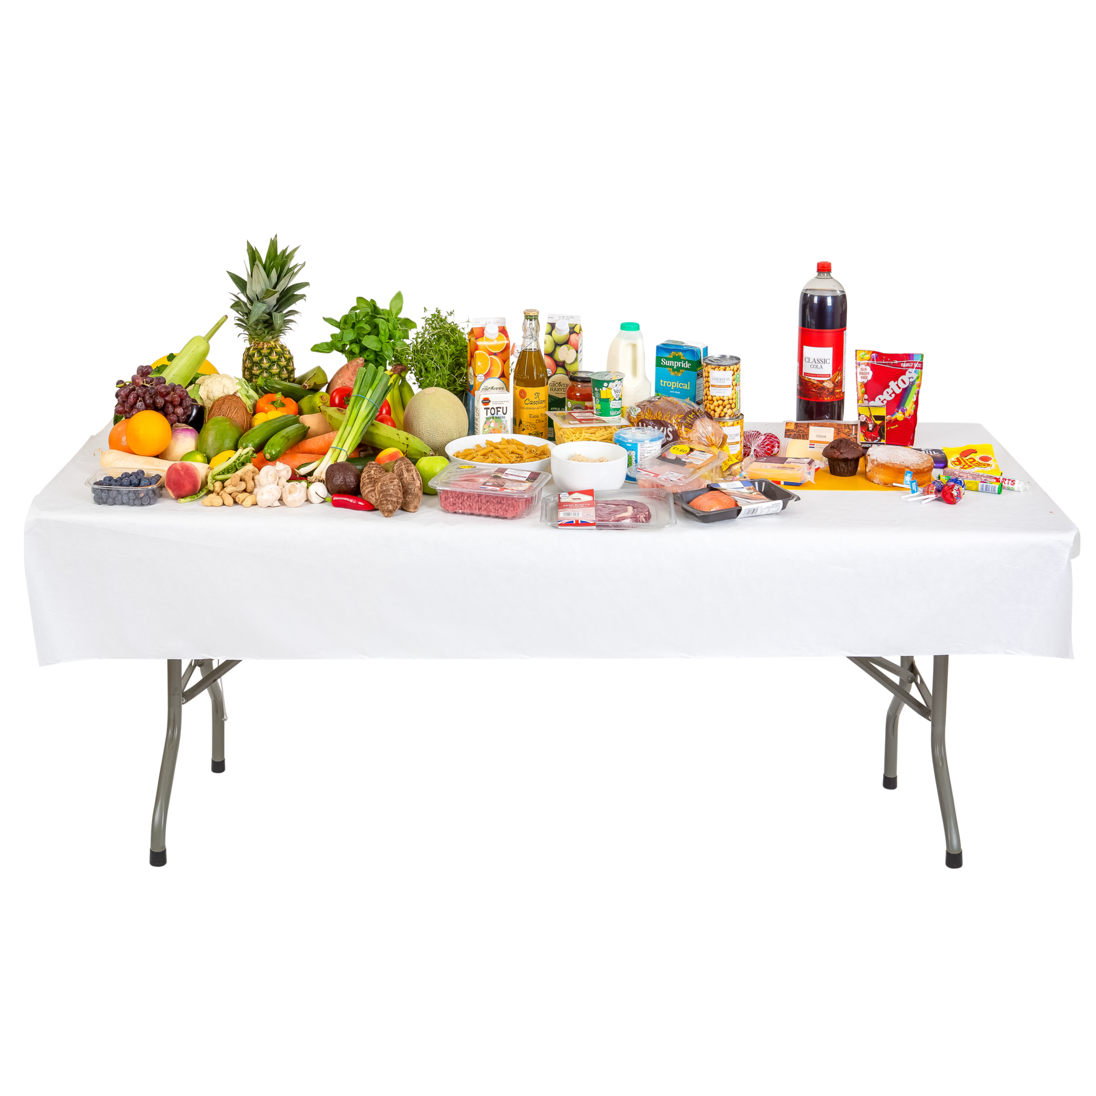 | There’ll be some refreshments!

