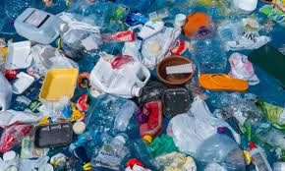**Are you passionate about ‘saying no to plastic’?**

Come along to The Department of Discovery, on the Ground Floor of Sparks: 78 Broadmead, Bristol BS1 3DS



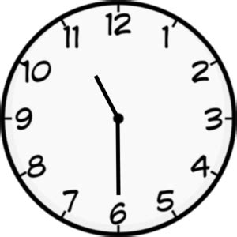

**Saturday 6th July** from 11.30am until 5.30pm

Watch a free screening of campaigner Beth Richard’s short animated film ‘Plastic Police’ – her response to the climate crisis.

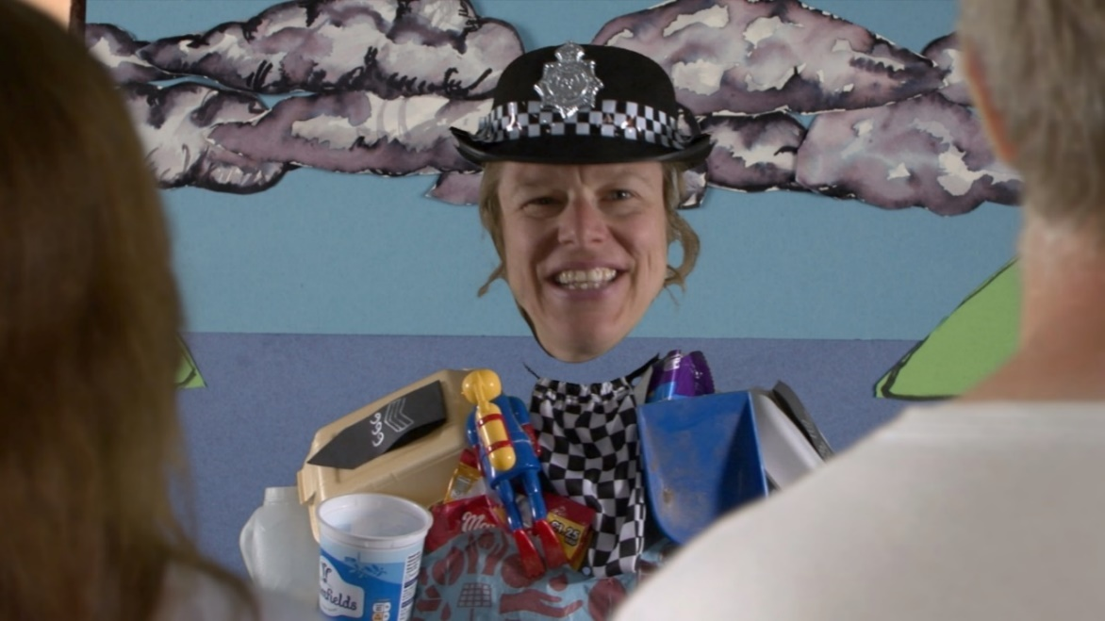

Followed by discussions on how we can move from passion to action together on saying no to plastic in our everyday lives! (Refreshments available)