AGM Meeting 29/01/24
Present: Isy O, Jo G, Ripper Liz, Frances, Sal, Ev, Peta, Sensi, Hannah, Vic, Annie, Vanessa, Maeve
Apologies
Harry, Sooooz, Becs, Rona, Emily, Wendy
- Voting in a new committee
New cowmittee roles
- New chair – Peta!!! – voted in unanimously with the current co-chairs abstaining.
- Vice chair – Sensi – voted in unanimously with the current co-chairs abstaining.
- Secretary – Jo G – voted in unanimously with the current co-chairs abstaining.
- Treasurer – Frances – voted in unanimously with the current co-chairs abstaining.
- Social sec – Alicia + Ripper Liz - voted in unanimously with the current co-chairs abstaining.
- Website developer – Tammi
- Politically secretary – Sensi
- Social media – Annie
Action: current committee to handover to new one 🪄
- Accounts overview
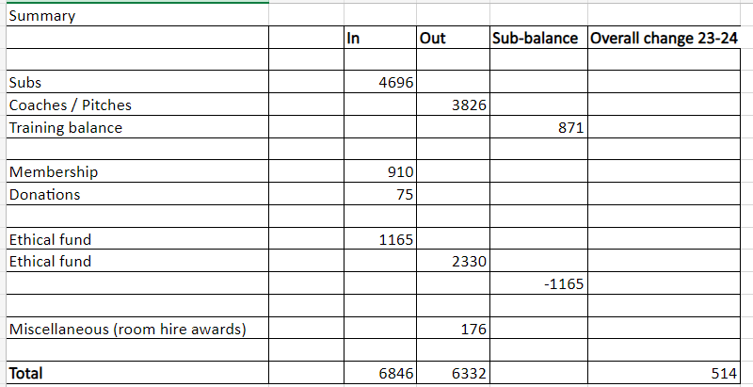
- We made a £871 "profit" on training, and collected £910 in membership fees. This enabled us to donate £1187 through the ethical fund to various causes including Palestine (HIRN, Gaza, Hebron friends) and cowfolk going through tough times, while still maintaining a healthy balance for ongoing costs.
- Jo told a very heart-warming story about how a woman who plants flowers and does gardening for the community on Stapleton road, who had had her spade stolen, and left a note asking if someone would be so kind as to return it.
- The cowgirls wrote underneath it ‘If you haven’t got your spade back, we’d like to buy you a spade.’
- Jo bought her a new spade with ethical fund money.
- To which Mary replied: ‘How did you know what spade I wanted?!’
- The end of the story: Mary from Stapleton Road is very grateful.

- The twisted oak brewery kindly gave us the donation money.

- Training
- Currently two sessions - game only Tuesday, coach led training on Thursday
- mark is main coach, bear has been helping out in last few months
- As we have had issues not all that long ago with an additional coach and a perceived lack of transparency about this situation amongst players it was discussed that we should be more transparent with any changes to coaching situations this time
- Agreed that having women coaching women is a great and empowering thing
- Suggested that chair/vice chair could have discussion with mark and bear about how they would like to work together, plans for coaching style/setup, and this could be fed back to players so they are aware
- Discussed the FA coaches conduct and coaching being inclusive of all abilities and fitness
- Agreed players should be encouraged to give feedback on coaching to coaches or committee, and for feedback to be taken on board
- Query whether a coach would be helpful on Tuesday sessions - however, this has been voted on in the past and agreed Tuesday is game only session
- Players are encouraged to ask others for informal coaching and advice in game only sessions if this is helpful for them
Actions
- Sensi to chat to Mark and Bear
- Sal and Annie to adapt fa code of conduct ‘for coaches’ to go in welcome letter
- People to be made aware of who the new committee is, and who they should go to if they want to give feedback on coaching.

- Development team?
- We should ask again to see if anyone wants to go into the development league.
- It was suggested that we take a group of cowgirls along to a development league to see if they like it. Minimum of 10 needed for a dev league team.
- It’s about letting people know that it could be a good place to go to develop their skills, and build confidence.
- A point was made that there’s no point in just putting a load of beginners in a team with no guidance.
- This could be an opportunity for someone who would like to lead / coach a team.
Action:
We should summarize what it’s about and encourage people to take part. We should also make a special effort to go along and support these matches to include people who go to it.

- Banner making
Let’s create another with the correct spelling of ‘antifascist’.
Could Zoe Gibbons facilitate it?
Action
Social secs to sort out a session, date, time and location

- Summer tournaments
We try to have a political anti-fascist tournament every summer. Everyone’s invited. People who have just become involved, longstanding members. Hardship fund can help out of you’d struggle with the costs.
- Glasgow haggis peeps and taties 5-7 April
- Leeds May day republica 3-5 May
- Anti-fascist network Belgium 5-7 JulyBelgium coming up – part of the ant-fa network – date?
- Trip to Manchester ‘Ball together now’ – gender inclusion – 12th – 14th July
Action: sensi to put dates out / ask a committee member if you’re interested.
- Christmas party
Kindly and creatively organised by Jo.
30+ attending
We must be out by 10pm
Actions:
- Please let Jo know if you’d like to help her decorate the place for 30 mins before the party, and to take down the stuff at 9.45ish
- If anyone would like to put together a playlist or bring speakers, please let Jo know
- Bring cans – no bottles (Vic wants to keep her job)
AOB
- Goalie gloves?
We voted to buy some more – unanimous.
Action: Hannah to take kit to Sally / Someone to buy goalie gloves
- Sponsorship by acorn?

- a community charity that mostly work on housing. I think they donated £75 the cricket club kit, and would like to do the same for football to be inclusive.
- However, it was pointed out that it wasn’t clear that the recent kit people bought was not actually the one we wear in the casual league – this should be made clearer
- Should we use acorn as a sponsor?
Action:
Peta to email acorn and say we are interested in a relationship, but don’t currently need a kit
- Lizzie W’s neighbour is making a film and would like female football players as extras.
- Possibly for up to 12 volunteers, film one eve from sunset to 10.00 – 10.30 pm. We have more questions for them but will keep you updated.
- What’s the plot?
- What we would get out of it? (money/recognition)
Action:
Lizzie to ask more questions
- Another opportunity to do first aid training
Vic mentioned that there was another opportunity to do first aid training . It’s on the 10th March – full day training £46, could be subsidised.
Action: Sensi to share the info to info chat – let a committee member know if you’re reinterested in taking part.
- Ev interested in doing a cow folk ball at the end of next summer (2025), end of next summer!
- To commemorate the sad passing of Cliff (previous plough landlord) 250 from the whole club fund to be donated to diabetes UK. As an acknowledgement of his legacy and what he brought to the cowfolk.

